**AI-POWERED MARKETING AUTOMATION: THE AGE OF PERSONALISED CUSTOMER EXPERIENCE AT SCALE**

**Abstract**

The establishment of the overall research proposal has ensured exploring literature-based knowledge on the way AI-powered marketing automation is comprehensively enhancing consumers' personalised experience. The determination of a background knwoeldge of the research area, establishing research questions, and determining methodological stances have been considered here. Moreover, a logical argument on the way of collecting secondary data sources, performing thematic analysis and setting a research timeline also has been considered here.

**Table of Contents**

1. Introduction 4

1.1 Discussion on the Key Areas of Research 4

1.2 Gap and Importance of the Research 4

1.3 Conceptual Development of the Research 4

2. Research Question 5

3. Literature Review 5

3.1 Emergence of Innovative Marketing Performance and Practices 5

3.2 Exploration of Critical Knowledge of Artificial Intelligence-Powered Marketing Automation 5

3.3 Transformed Landscape of Consumers' Personalised Experience with AI-Powered Marketing Automation 6

4. Methodology and Research Design 6

4.1 General Methodological Position 6

4.2 Research Method 7

4.3 Research Approach 7

4.4 Research Design 7

4.5 Data Collection Method 7

5. Approach to Analysis 8

6. Ethical Consideration 8

7. Research Timetable 8

Reference List 10

# 1. Introduction

## 1.1 Discussion on the Key Areas of Research

The primary or key areas considering which the overall research will be established represent critical knowledge on Artificial Intelligence and the way it can be integrated into marketing activity. Other key areas ask for marketing automation and personalised customer experience through marketing which is powered and influenced by Artificial Intelligence. Literature-based knowledge states in the key research area that AI-powered marketing automation is entitled sophisticated algorithms and machine learning techniques (Reddy, 2022). It ensures the analysis of consumers' data, predicts their behaviour and eventually automates the marketing process. Areas of literature which the research also involves represent AI and the way the disruptive force has revolutionised the industry as well as changed business practices (Kumar *et al.,* 2024). The specific areas of interest the study considers indicate the adaptation of disruptive technology and the way it has changed the marketing practices for organisations. The exploration of knowledge regarding the way improvement in the marketing process has enabled organisations to provide consumers with a personalised shopping experience by exploring their preferences, intentions, sentiments and purchase intent, these specific areas of interest the study will also consider here (Reddy, 2022).

## 1.2 Gap and Importance of the Research

Exploring research and literature-based knowledge have identified the gap that there is a lesser knowledge on the way organisations can integrate AI-powered marketing tactics to enhance consumers' experience and offer them personalised service (Vihavainen, 2024). Another set of gaps identified from the existing research represents AI-powered digital marketing tools and the way organisations are integrating them into the business to understand consumers' preferences and intentions (Haleem *et al.,* 2022). The research itself is interesting due to the limited amount of research that has been done on AI-powered tools and technology and important in the manner where researching in those areas will help to explore a logical understanding and vast amount of knowledge on Artificial Intelligence. Performing this research will also be significant to gaining knowledge on the way artificial intelligence is making a difference in the business process, directly influencing marketing outcomes and advancing personalised experiences for consumers (Chintalapati and Pandey, 2022). In the chosen area of literature where knowledge of AI, its marketing tools and tactics along with the personalised experience of consumers are explored, the research will contribute by establishing a logical connection between each of the variables and by justifying the usefulness of the disruptive technology towards the betterment of both consumer and organisation.

## 1.3 Conceptual Development of the Research

The purpose of conceptually developing the field of research on AI-powered marketing automation and consumers' personalised experience will be conducted by collecting previous literature-based knowledge and research performed by authors. The purpose of performing the research is to keep organisations and large industries informed on the way they can engage with AI-powered marketing automation methods to enhance their business practices by engaging and offering consumers a personalised experience, the research will determine to achieve this purpose here. To explore literature-based knowledge that discusses Artificial Intelligence, its benefits and drawbacks, and the usage of disruptive technology in marketing practices, such literature review will be considered here (Ma and Sun, 2020). Moreover, with the approach of collecting secondary data sources mostly journals, articles and website-based knowledge, thematic analysis will ensure answering the research question here. The overall writing will be critical and argumentative and will justify the way in a broad spectrum, organisations can adapt to AI-powered marketing automation altogether.

## 2. Research Question

How does the integration of AI-powered marketing automation within organisations ensure the establishment of a personalised experience for consumers comprehensively?

# 3. Literature Review

## 3.1 Emergence of Innovative Marketing Performance and Practices

A general observation which can be conducted on innovative marketing performance and practices indicates the adaptation of technological innovation which ensures adding changes and improvement in product and service offerings (Edeh *et al.,* 2020). In marketing performance, historical narrative indicates the allocation of technological innovation as well as the offering of personalised experiences to consumers. However, Purchase and Volery (2020) have argued that marketing innovation regarding performance and practice has emerged with new price-setting strategies, advertising promotion, new distribution channels and also with innovative marketing information systems. The ability of organisations to establish new solutions by understanding the demand of consumers, performing critical analysis of their intentions, preferences and expectations and eventually setting the marketing mix with technological integration, essentially justifies the emergence of innovation in marketing performance. However, the theme is debatable by Chandra *et al.,* (2022) that in marketing, personalisation through understanding the needs and expectations of consumers is an innovation that has emerged with technological automation and such practices are essentially reducing customer fatigue and the time in making purchase choices. This is essentially occurring with the emergence of technology like Artificial Intelligence, Machine Learning, Internet of Things, Blockchain, Big Data and Automation altogether. A narrowed-down argument justified by Babatunde *et al.,* (2024) represents that innovation in marketing activity with technology is happening based on the ability of the advanced technology to analyse vast amounts of consumer data, set new marketing mix, tactics, product and pricing specifications, promotional attributes and eventually performing targeted advertising, product recommendation and by driving deeper engagement altogether.

## 3.2 Exploration of Critical Knowledge of Artificial Intelligence-Powered Marketing Automation

A greater debate emerging from the historical narrative of Barari *et al.,* (2022) is that AI has emerged as a disruptive revolution that has changed marketing strategies for organisations by enhancing business models, sales ability, customer service and customer behavioural attributes. The general observation is debatable because the usage of AI tools is known to mimic human behaviour which ensures the establishment of unique customer behaviour. On the contrary, Yau *et al.,* (2021) have stated that with the approach of advanced technology in mimicking human intelligence and behaviour, the usage of intelligence marketing ensures the curation of massive amounts of data and information regarding the marketing mix in terms of establishing new marketing strategy for organisations.

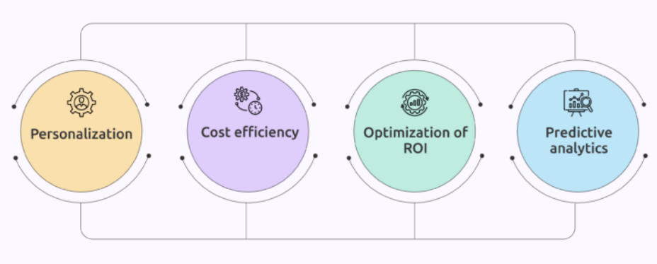

**Figure 1: Artificial Intelligence-Powered Marketing Automation**

(Source: Kadasah, 2023)

Such capability of AI is eventually manifesting personalisation and ensuring a response to the ever-changing business environment. The exploration of the comprehensive secondary-research-based literature findings narrows down the argument by stating that automation in the marketing activity has essentially emerged with the usage of AI-powered social media, marketing trend analysis tools and also with the critical exploration of the competitive marketplace through digital platforms (Kadasah, 2023). Thus, the exploration of literature-based knowledge essentially justifies the argument that Artificial Intelligence with the adaptation of human intelligence has emerged as a disruptive tool. This essentially with effective evolution and innovation has become an automated segment that has enhanced the marketing attributes, performance and tactics for organisations to establish their position, gain consumers preferences and also in making business decisions in an automated manner.

## 3.3 Transformed Landscape of Consumers' Personalised Experience with AI-Powered Marketing Automation

The bottom-up method of the inductive methodology used in establishing the literature review has emerged to explore how innovative marketing performance by integrating AI-powered marketing automation has transformed the landscape of consumer experience. It has been debated by Reddy (2021) that the formulation of personalised experience for consumers with the integration of AI is occurring with the utilisation of predictive analytics that is AI-powered as well as with the encompassing of large volumes of consumer data collected from various sources in an automated manner. However, the debate of Kaperonis (2024) states the knowledge that personalised experience infused with automation is also occurring with AI-powered marketing automation where automated platforms like chatbots are offering round-the-clock customer service and personalised product suggestions.

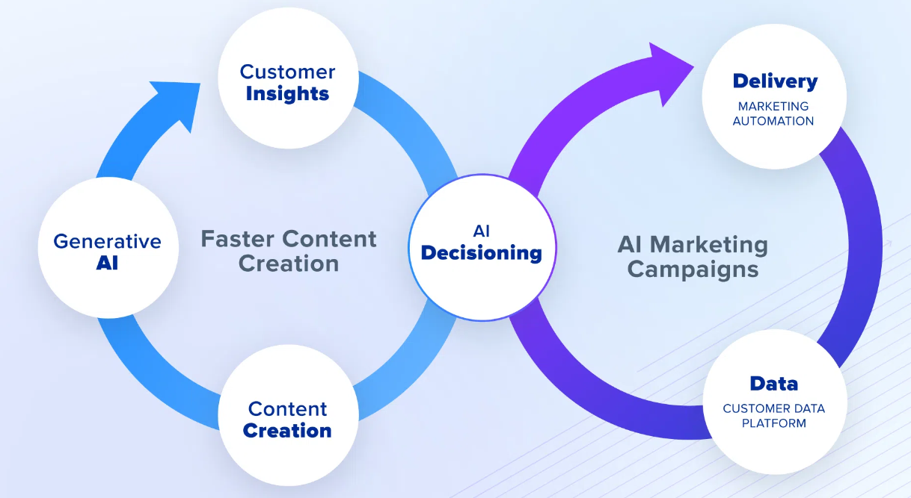

**Figure 2: Consumers' Personalised Experience with AI-Powered Marketing Automation**

(Source: Altan and Milson, 2024)

Thus, the argument here ensures answering the research question by addressing the way leveraging consumer data, AI is performing marketing automation, understanding consumers' behaviour, and purchase intention, predicting future action and eventually tailoring marketing messages that resonate with individual consumers. Lastly, the historical narrative of Altan and Milson (2024) develops the school of thought that in e-commerce platforms, AI is ensuring to perform in an automated manner to not only provide consumers with personalised recommendations of products and services but it ensure running marketing automation with streamline content according to user preference.

# 4. Methodology and Research Design

## 4.1 General Methodological Position

Research methodology is considered a framework which enables a researcher to plan, design and structure a study to collect and analyse data to answer a research question (Pandey and Pandey, 2021). The general methodological position that the researcher will consider to answer the research question represents the Qualitative Research Method, Inductive Research Approach, Descriptive Research Design, Secondary Data Collection Method and Thematic Data Analysis Method altogether (Pandey and Pandey, 2021). The reason behind choosing each of these methodological stances justifies the fact that the researcher will minimise the expenditure, will ensure facilitating smooth and logical progress of the research along with the collection of relevant data that will answer the research question in a justified manner.

## 4.2 Research Method

The purpose of the researcher in integrating and utilising qualitative research method has entailed the factor of studying natural phenomena, contexts different manifestations and perspectives regarding a research area (Busetto *et al.,* 2020). Similarly, to explore the perspective and context regarding AI-powered marketing automation and the way consumers achieve personalised experience, an adaptation of such knowledge stipulates the usage of qualitative research methods here. As the quantitative research method is entitled to the study of numbers and volumes, the qualitative method will enable the researcher to utilise its characteristics of discovering reasons, observing patterns, and the identification of significant knowledge (Busetto *et al.,* 2020). This essentially justifies the cooperation of the research method within the study here.

## 4.3 Research Approach

The inductive research approach is focused towards the utilisation of a bottom-up approach of performing observation and exploration of general knowledge to the establishment of a logical and justified research theory or outcome. The approach essentially represents the characteristics of seeing and reflecting on patterns, exploring hunches, identifying key themes and comparing research units (O'Kane *et al.,* 2021). It essentially represents a relation with the study based on its strength in performing critical observation on innovation in marketing, technological advancement to the development of knowledge on AI-powered marketing automation and consumers' personalised experience. However, the limitation of the approach due to relying on patterns might generate barriers for the researcher in testing the theory or answering the research question. Still, deductive will not be chosen here due to its purpose of testing hypotheses where a study regarding AI-powered marketing automation has been researched previously and requires new research and analysis to answer a new research question.

## 4.4 Research Design

The researcher will ensure the application of descriptive research design here which is entitled with the purpose of exploring and representing research findings or outcomes in a described and textural format for better comprehension. Here, with the similar attribute of answering the research question on AI-powered marketing automation and the way it enhances consumers' personalised experience, the knowledge will be represented descriptively by considering the qualitative dataset.

## 4.5 Data Collection Method

There are mainly two types of data collection methods: primary and secondary (Mazhar *et al.,* 2021). As primary data is focused towards the collection of real-time information by communicating or connecting with research participants or demographics, secondary data collection is focused towards the collection of journal and article-based knowledge gathered by previous researchers to answer a new research question. Here, with the similar purpose of exploring previous research-based knowledge on the chosen area, the researcher will consider the collection of secondary resources altogether. This is because, to answer the research question asking the way AI-powered marketing automation has changed and improved personalised experience for consumers, a comprehensive set of research has been performed by previous researchers. Thus, the collection of journals, articles, websites and book-related sources as secondary data will be considered here.

# 5. Approach to Analysis

Based on the purpose of the researcher in analysing qualitative secondary data, the application of the Thematic analysis method will be considered here. It is essentially entitled to the attribute of finding similar themes and knowledge by exploring the patterns presented in the collected dataset (Braun and Clarke, 2023). Moreover, with the establishment of the themes, the researcher will ensure answering and discussing each of the themes critically by utilising secondary data sources. This will eventually ensure a logical exploration of the collected data as well as a thematic analysis of the established themes in the research area.

# 6. Ethical Consideration

The purpose of the researcher in following ethical principles is only essential when the researcher is collecting primary data sources. However, for the secondary data sources which are already available and publicly accessible, the researcher will not be required to consider ethical principles and practices here (Graham *et al.,* 2021). Still, the approach of the researcher in ensuring that the collected data has not discriminated against any particular group of individuals or only the accessible data has been gathered, the effective protection of the collected data by following the General Data Protection Regulation (GDPR) will be considered here.

# 7. Research Timetable

|  |  |  |  |  |  |  |  |
| --- | --- | --- | --- | --- | --- | --- | --- |
| **Research Activity** | **Week 1** | **Week 2** | **Week 3** | **Week 4** | **Week 5** | **Week 6** | **Week 7** |
| **Determination of research aim and objectives** |  |  |  |  |  |  |  |
| **Collection and evaluation of literature-based knowledge** |  |  |  |  |  |  |  |
| **Establishing research methodology** |  |  |  |  |  |  |  |
| **Collection of secondary data** |  |  |  |  |  |  |  |
| **Performing thematic analysis** |  |  |  |  |  |  |  |
| **Development of conclusion and recommendation** |  |  |  |  |  |  |  |
| **Final Submission** |  |  |  |  |  |  |  |

# Reference List

Altan, B. and Milson, S., 2024. *AI-Powered Data Revolution: Navigating the Big Data Landscape* (No. 11898). EasyChair.

Babatunde, S.O., Odejide, O.A., Edunjobi, T.E. and Ogundipe, D.O., 2024. The role of AI in marketing personalization: A theoretical exploration of consumer engagement strategies. *International Journal of Management & Entrepreneurship Research*, *6*(3), pp.936-949.

Barari, M., Quach, S. and Thaichon, P., 2022. New developments in artificial intelligence (AI)-powered products in marketing. In *Artificial Intelligence for Marketing Management* (pp. 55-75). Routledge.

Braun, V. and Clarke, V., 2023. Toward good practice in thematic analysis: Avoiding common problems and be (com) becoming a knowing researcher. *International Journal of transgender health*, *24*(1), pp.1-6.

Busetto, L., Wick, W. and Gumbinger, C., 2020. How to use and assess qualitative research methods. *Neurological Research and Practice*, *2*(1), p.14.

Chandra, S., Verma, S., Lim, W.M., Kumar, S. and Donthu, N., 2022. Personalization in personalized marketing: Trends and ways forward. *Psychology & Marketing*, *39*(8), pp.1529-1562.

Chintalapati, S. and Pandey, S.K., 2022. Artificial intelligence in marketing: A systematic literature review. *International Journal of Market Research*, *64*(1), pp.38-68.

Edeh, J.N., Obodoechi, D.N. and Ramos-Hidalgo, E., 2020. Effects of innovation strategies on export performance: New empirical evidence from developing market firms. *Technological Forecasting and Social Change*, *158*, p.120167.

Graham, M., Hallowell, N., Solberg, B., Haukkala, A., Holliday, J., Kerasidou, A., Littlejohns, T., Ormondroyd, E., Skolbekken, J.A. and Vornanen, M., 2021. Taking it to the bank: the ethical management of individual findings arising in secondary research. *Journal of medical ethics*, *47*(10), pp.689-696.

Haleem, A., Javaid, M., Qadri, M.A., Singh, R.P. and Suman, R., 2022. Artificial intelligence (AI) applications for marketing: A literature-based study. *International Journal of Intelligent Networks*, *3*, pp.119-132.

Kaperonis, S., 2024. How artificial intelligence (AI) is transforming the user experience in digital marketing. In *The use of artificial intelligence in digital marketing: Competitive strategies and tactics* (pp. 117-141). IGI Global.

Kumar, V., Ashraf, A.R. and Nadeem, W., 2024. AI-powered marketing: What, where, and how?. *International Journal of Information Management*, p.102783.

Ma, L. and Sun, B., 2020. Machine learning and AI in marketing–Connecting computing power to human insights. *International Journal of Research in Marketing*, *37*(3), pp.481-504.

Mazhar, S.A., Anjum, R., Anwar, A.I. and Khan, A.A., 2021. Methods of data collection: A fundamental tool of research. *Journal of Integrated Community Health (ISSN 2319-9113)*, *10*(1), pp.6-10.

O’Kane, P., Smith, A. and Lerman, M.P., 2021. Building transparency and trustworthiness in inductive research through computer-aided qualitative data analysis software. *Organizational Research Methods*, *24*(1), pp.104-139.

Pandey, P. and Pandey, M.M., 2021. *Research methodology tools and techniques*. Bridge Center.

Purchase, S. and Volery, T., 2020. Marketing innovation: a systematic review. *Journal of Marketing Management*, *36*(9-10), pp.763-793.

Reddy, S.R.B., 2021. Predictive Analytics in Customer Relationship Management: Utilizing Big Data and AI to Drive Personalized Marketing Strategies. *Australian Journal of Machine Learning Research & Applications*, *1*(1), pp.1-12.

Reddy, S.R.B., 2022. Enhancing Customer Experience through AI-Powered Marketing Automation: Strategies and Best Practices for Industry 4.0. *Journal of Artificial Intelligence Research*, *2*(1), pp.36-46.

Vihavainen, S.M., 2024. *AI-powered marketing automation: exploring the factors affecting implementation in a large company* (Master's thesis).

Yau, K.L.A., Saad, N.M. and Chong, Y.W., 2021. Artificial intelligence marketing (AIM) for enhancing customer relationships. *Applied Sciences*, *11*(18), p.8562.